# User Manual

## Introduction

The Library Path Searching System (LPSS) is a web system that can help you search locations of books and find the shortest path to fetch these books in a library. For librarians, it will be very practical to reduce the work of returning books back to the shelves and managing library. This manual guides general users and staffs to use this system.

## Authority

C:\Users\Sidney\Desktop\UserMaunal\NOUSEFORGENERALUSER.png

As you can see, this is main navigation bar of the website. Different types of people have different authorities to access those pages.

If you click on the page without authority, there will be a warning.

|  |  |  |  |  |  |
| --- | --- | --- | --- | --- | --- |
| Pages | General user | Junior Librarian | Senior Librarian | DB Admin | Curator |
| People | NO | YES | YES | YES | YES |
| Books | NO | NO | YES | YES | YES |
| Maps | NO | NO | NO | YES | YES |
| Others | YES | YES | YES | YES | YES |

## Manage Personal Information

### Personal Webpage Introduction

Click ‘Personal’ on the main navigation bar, this will lead you to the personal page.

In this webpage, you can **change password**, **view and modify favorite list**, **view borrowed list and to-do list**.

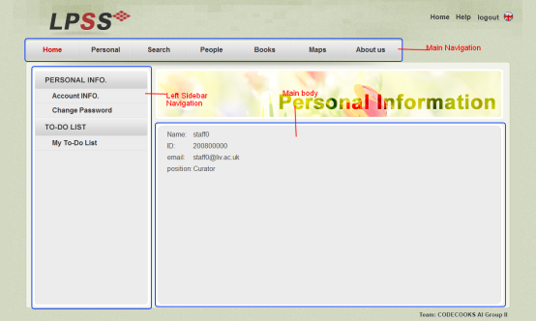

|  |  |
| --- | --- |
| C:\Users\Sidney\Desktop\UserMaunal\GeneralUserNavigation.png | C:\Users\Sidney\Desktop\UserMaunal\StaffNavigation.png |
| For General Users | For Staffs |

The left sidebars for general users and staffs are different.

|  |  |
| --- | --- |
| If you are a general user, you can do | If you are a staff, you can do |
| 1. View personal information 2. Change password 3. View Borrowed list 4. View favorite list | 1. View personal information 2. Change password 3. View and modify to-do-list |

**Notice**: Modify favorite list is not in this page, the function is on the search for shortest path section (‘Search’ page).

## Search for shortest path

### Search Webpage Introduction

Click ‘Search’ on the main navigation bar, it will lead you to the Search page. On this page a user could **search for books** and get the **shortest path** of these books.

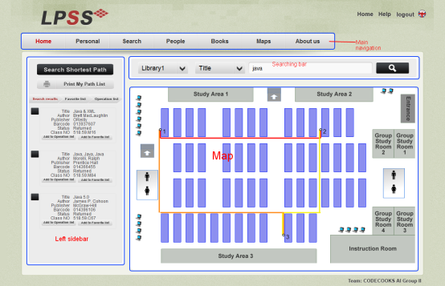

Here is a searching Bar which could be used to search for books in library:



**Search for books steps:**

1. Choose the library: The library name that your books would be.
2. Choose search category: This could be book title, author or barcode.
3. Enter the key word: Not case sensitive.

Simply click on the search icon on the right, the result will be displayed at the left of the web page.

**Get shortest path**

Just click the button below the book named ‘Add to Operation list’ you can add the book to operation list. Then the path with this book will be displayed on the map area.

**Display**

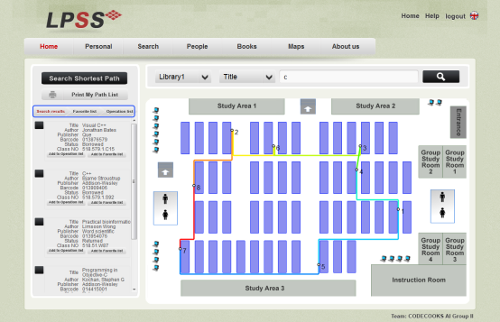

Click on the tabs to see the search result, favorite list or operation list.

In the favorite list, the book could be modified like delete from favorite list or add to operation list.

The paths between each two books are in different colors. It is easy to distinguish.

## Staff Management

All the members including general users and staffs can be viewed by every staff, but only the curator could modify their accounts.

### People Webpage Introduction

Click ‘People’ on the main navigation bar, this will lead you to the staff management page. In this web page a manager could **view all users** and **manage staff**.

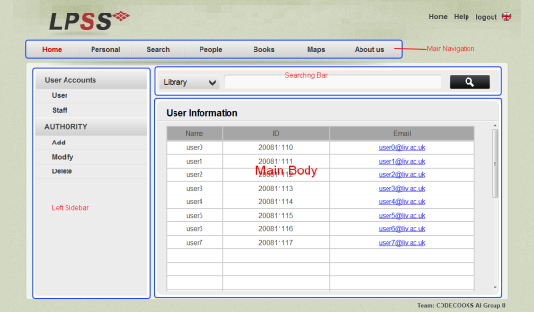

|  |  |
| --- | --- |
| C:\Users\Sidney\Desktop\UserMaunal\CuratorPeople.png |  |
| Curator | Other staffs |

There is little different between curator and other staff on left sidebar navigation.

So only the curator has the authority to manage people.

All the staff basic information could be viewed by other staff.

### Staff Management

There are three type operations that could be used to modify staff: **add**, **modify** and **delete**.

#### Add Staff

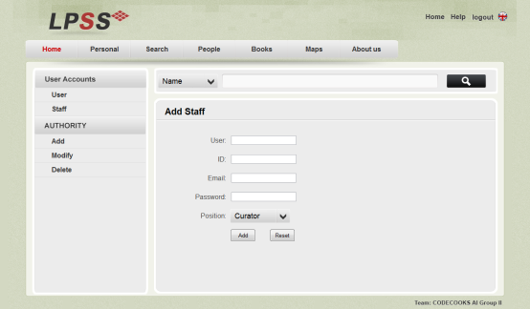

If and only if the conditions bellow are satisfied the staff could be add:

1. User name could not be the same with other staffs
2. User ID could not be the same with other staffs, ID should be numbers.

The reset button is for cleaning everything entered.

#### Modify Staff

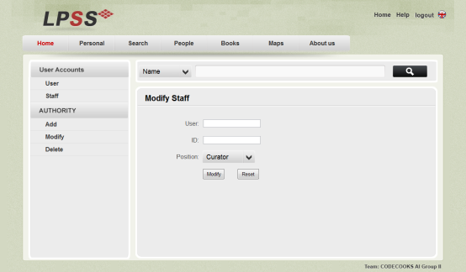

If and only if the following conditions are satisfied, then the staff’s position could be changed:

1. The user name entered should exist.
2. The ID of the user must be the correct

The reset button is for cleaning everything entered.

#### Delete Staff

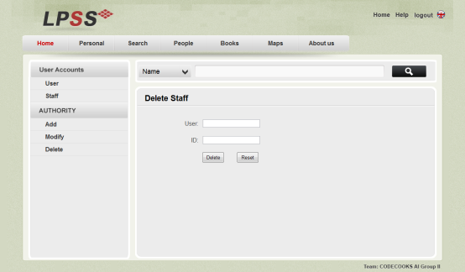

If and only if the following conditions are satisfied, then the staff could be deleted:

1. The user name entered should exist.
2. The ID of the user must be the correct

The reset button is for cleaning everything entered.

## Add Book

Only Senior Librarian, Database Administer and curator could add a book to the database.

### Book Webpage Introduction

Click ‘Books’ on the main navigation bar, it will lead you to the book adding page. Senior Librarian can use this page to **add books** to the database.

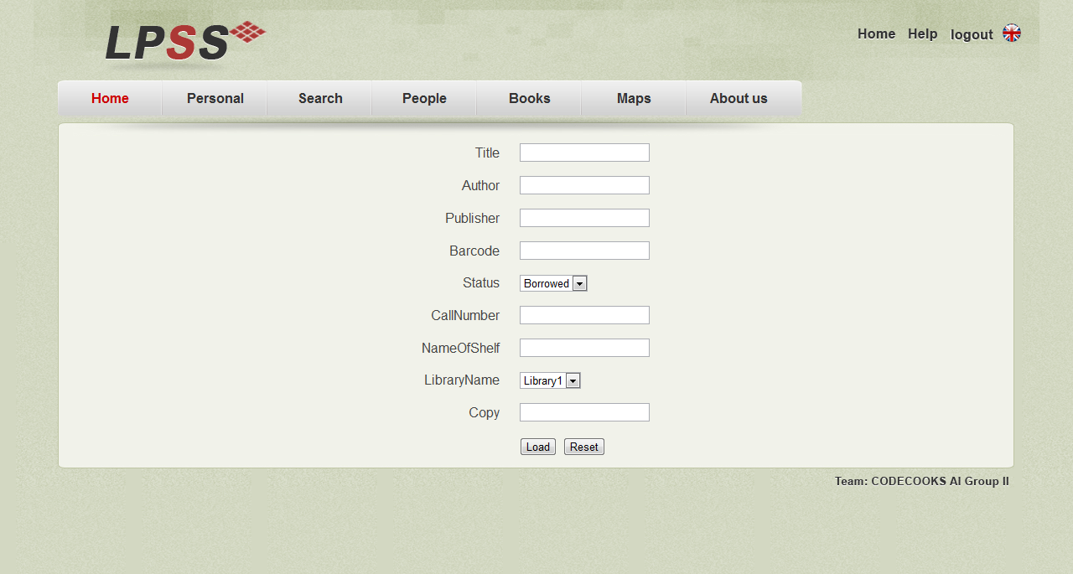

Senior Librarian can use this page to add books to the database, if and only if the barcode and callNumber of the book are both not the same with other books and the copy of the book is integer, then the book could be added.

## Edit Map

Only the curator and database administer could edit a map. This function is not fully implemented that the map cannot be stored to the database.

### Map Webpage Introduction

Click ‘Maps’ on the main navigation bar, this will lead you to the map edit page. Database administer can use this page to **edit maps** of the database.

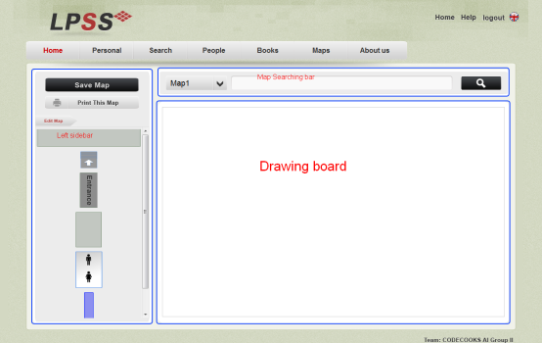

### Edit Map

There are stuffs that a library may have in the left sidebar.

**Add stuff to the map**: Simply drag the stuff to the drawing board.

**Draw map**: In the main body of drawing board, hold the left button of mouse and move.

**Add text**: Double click the main body of the drawing board to add some texts.

**Notice:** As this function is implemented using HTML5, it can only be used on the browser which supports HTML5 such as chrome. The map saving and map printing functions have not be implemented yet, may add them in further versions.

## About Us

Click ‘About us’ on the main navigation bar, it will lead you to webpage which contains information about us. If you wish to contact us, there is some contact information.

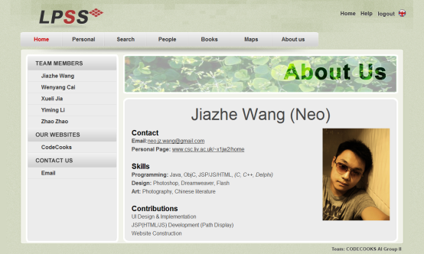

## Section not implemented:

**Search for staff**



This searching bar is used for searching for staffs and users in the library.

**Search for library map**



This searching bar is used to search for map of a particular library.

These functions above have not been implemented yet. Please wait for further version of the system and sorry about any inconvenience.